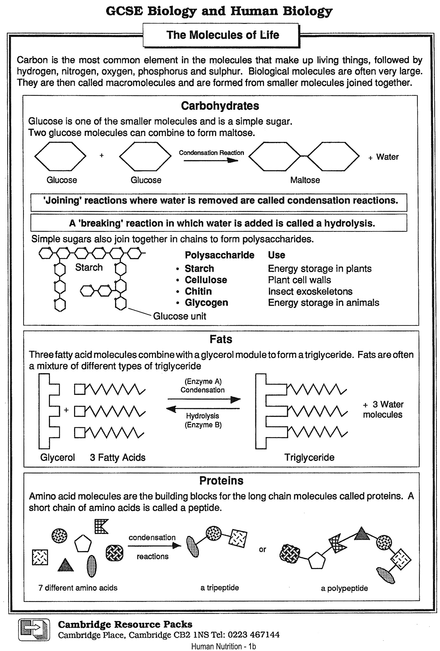

The Molecule of Life

- Complete the table below, which lists some information about the main groups of molecules associated with biological processes. For the empty brackets you will need to provide an example that performs the given function.

Group | Carbohydrates | Lipids
Composition (elements) | C H O | C H O | C H O N S
Examples | Simple  Eg  More complex  Eg  Very complex  Eg | Fats, oils | Amylase  Haemoglobin
Basic units (monomer) | Monosaccharides |  | Amino Acids
Multiple Units (polymer) |  | Triglycerides | Dipeptides
Functions | Energy sources  Energy storage  ( )  Structural  ( ) | Energy sources  Energy storage Insulation  ( )  Waterproofing  Membranes | Contractile ( )  Catalytic ( )  Structural  Messengers  Membranes  ( )

- Complete the following paragraph, using the words provided below. Each word may be used once, or not at all.

Simple smaller polysaccharides macromolecules
Base amino acids glycerol starch
Triglycerides condensation

Biological molecules are often ____, built from ____ molecules which join together through ____reactions. ____ are built from simple sugars; ____ is an example. Peptides and proteins are built from ____. Fats are built from ____ and fatty acids.

